🔍 Missing Values Check:

date 0
application_name 0
daily_active_users 0
session_count 0
avg_session_duration 0
like_count 1
share_count 0
download_count 0
comment_count 0
error_count 0
day_of_week 0
month 0
is_weekend 0
release_flag 0
dtype: int64

🔁 Number of duplicate rows: 0
/usr/local/lib/python3.12/dist-packages/IPython/core/pylabtools.py:151: UserWarning: Glyph 128200 (\N{CHART WITH UPWARDS TREND}) missing from font(s) DejaVu Sans.fig.canvas.print_figure(bytes_io, **kw)
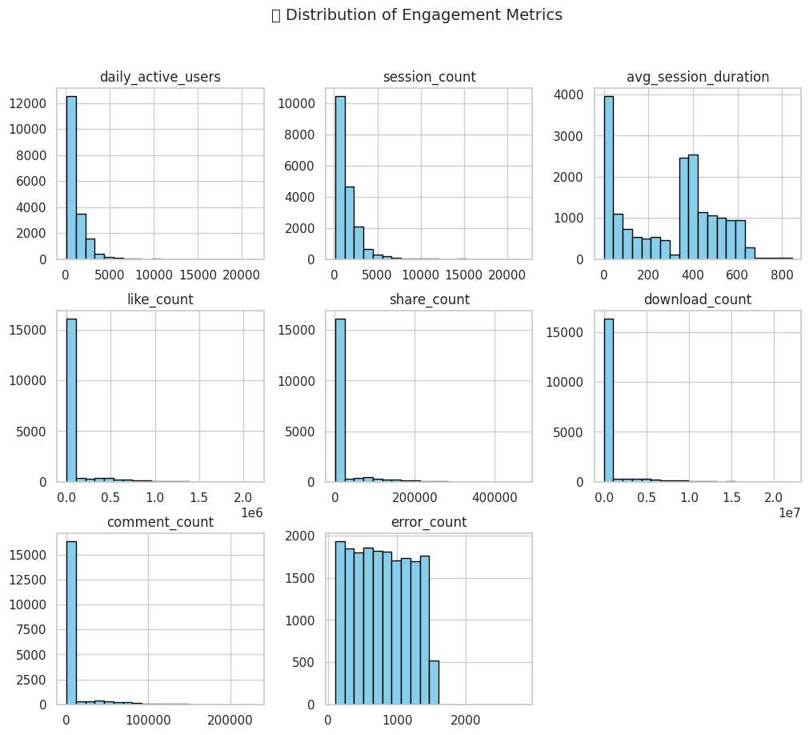

/usr/local/lib/python3.12/dist-packages/IPython/core/pylabtools.py:151: UserWarning: Glyph 128172 (\N{SPEECH BALLOON}) missing from font(s) DejaVu Sans.
fig.canvas.print_figure(bytes_io, **kw)
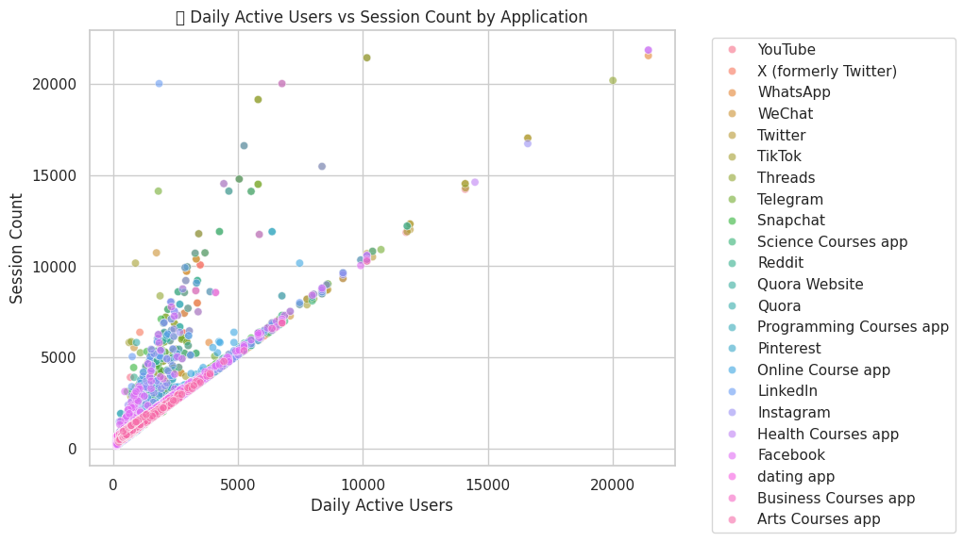

/usr/local/lib/python3.12/dist-packages/IPython/core/pylabtools.py:151: UserWarning: Glyph 128198 (\N{TEAR-OFF CALENDAR}) missing from font(s) DejaVu Sans.
fig.canvas.print_figure(bytes_io, **kw)
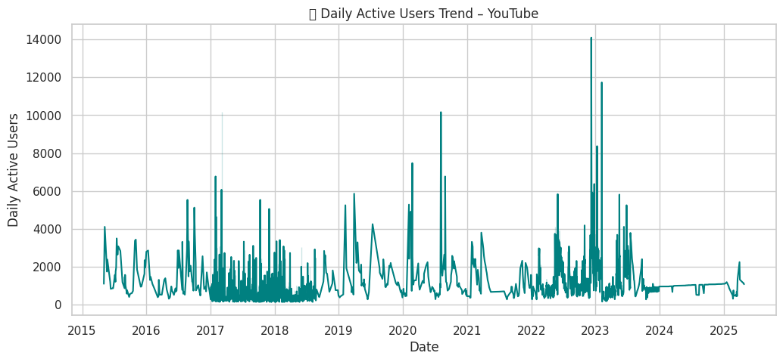

/usr/local/lib/python3.12/dist-packages/IPython/core/pylabtools.py:151: UserWarning: Glyph 128293 (\N{FIRE}) missing from font(s) DejaVu Sans.
fig.canvas.print_figure(bytes_io, **kw)
